Name: _________Christopher Guay______________

1. SQL (please provide the SQL used to create and load your database)

Use ist210cug39;

Create table Records (id int not null, artist varchar(20), type varchar(20), name varchar(40), stock smallint, price float);

insert into Records (id, artist, type, name, stock, price) values (1000, 'Journey', 'Album', 'Escape', 3, 19.99);

insert into Records (id, artist, type, name, stock, price) values (1001, 'Journey', 'Album', 'Frontiers', 10, 20.15);

insert into Records (id, artist, type, name, stock, price) values (1002, 'Journey', 'Album', 'Trial by Fire', 2, 15.99);

insert into Records (id, artist, type, name, stock, price) values (1003, 'Journey', 'CD', 'Revelation', 5, 15.99);

insert into Records (id, artist, type, name, stock, price) values (1004, 'Journey', 'CD', 'Infinity', 0, 16.50);

insert into Records (id, artist, type, name, stock, price) values (1005, 'Kiss', 'Album', 'Love Gun', 2, 19.99);

insert into Records (id, artist, type, name, stock, price) values (1006, 'Kiss', 'Album', 'Destroyer', 8, 19.99);

insert into Records (id, artist, type, name, stock, price) values (1007, 'Kiss', 'Album', 'Alive 2', 3, 25.99);

insert into Records (id, artist, type, name, stock, price) values (1008, 'Kiss', 'CD', 'Dressed to Kill', 3, 13.99);

insert into Records (id, artist, type, name, stock, price) values (1009, 'Kiss', 'Single', 'Beth', 0, 12.99);

insert into Records (id, artist, type, name, stock, price) values (1010, 'Kiss', 'Single', 'Detroit Rock City', 4, 14.99);

insert into Records (id, artist, type, name, stock, price) values (1011, 'Kiss', 'Single', 'Rock and Roll all Night', 6, 12.99);

insert into Records (id, artist, type, name, stock, price) values (1012, 'Elton John', 'Album', 'Goodbye Yellowbrick Road', 3, 30.00);

insert into Records (id, artist, type, name, stock, price) values (1013, 'Elton John', 'Album', 'Captain Fantastic', 2, 18.00);

insert into Records (id, artist, type, name, stock, price) values (1014, 'Elton John', 'Album', 'Elton John', 3, 15.99);

insert into Records (id, artist, type, name, stock, price) values (1015, 'Elton John', 'Album', 'Caribou', 0, 21.99);

insert into Records (id, artist, type, name, stock, price) values (1016, 'Elton John', 'CD', 'Goodbye Yellowbrick Road', 3, 23.99);

insert into Records (id, artist, type, name, stock, price) values (1017, 'Elton John', 'CD', 'Rock of the Westies', 6, 21.99);

insert into Records (id, artist, type, name, stock, price) values (1018, 'Elton John', 'Single', 'Harmony', 3, 12.99);

insert into Records (id, artist, type, name, stock, price) values (1019, 'Elton John', 'Single', 'Someone Saved my Life', 2, 11.99);

insert into Records (id, artist, type, name, stock, price) values (1020, 'Elton John', 'Single', 'Your Song', 5, 16.99);

1. Provide a screen capture showing a “describe” of your table

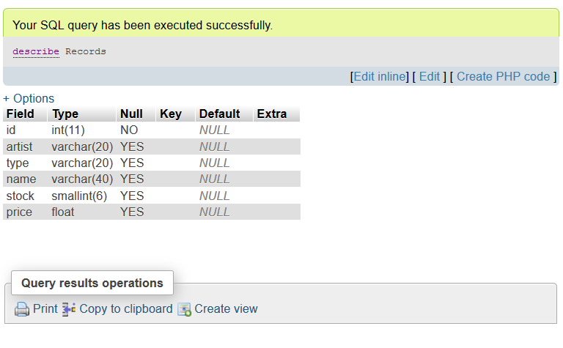

1. Provide a screen capture of a “select *”

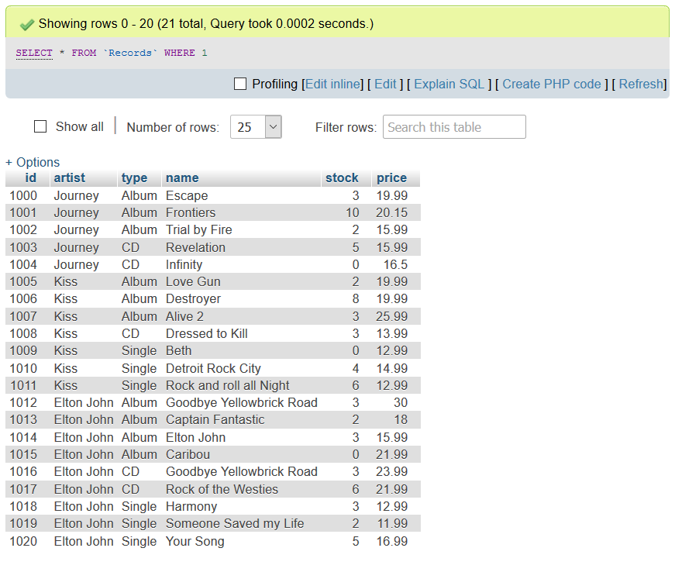

1. Provide screen captures and SQL for:

* What stock items do we need to reorder (ie, we have none) ?

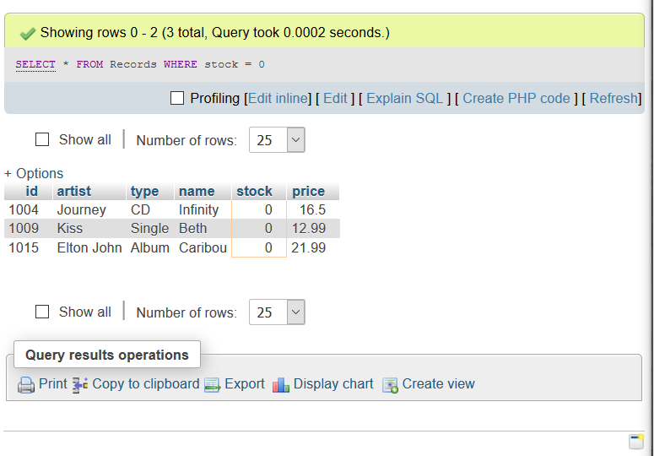

* In order to sell more, perhaps we need to lower the price on items where we have 5 or more. Which ones ?

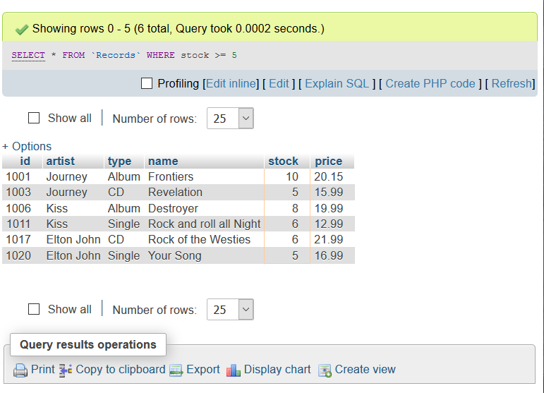

* How many total Singles, Records and CD’s do we have in stock ?

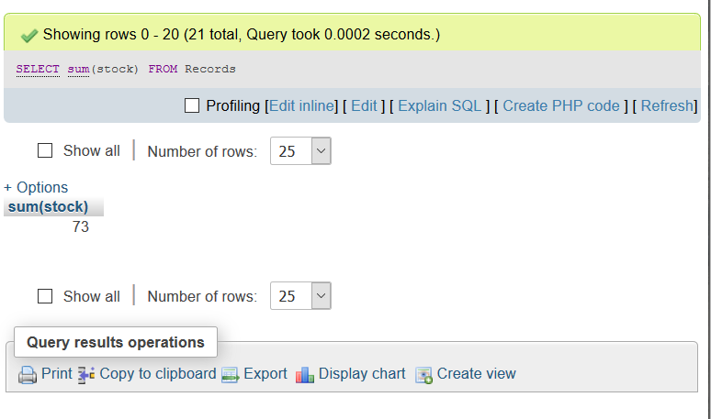

* Any sql/screenshots that show your validation of inserted data

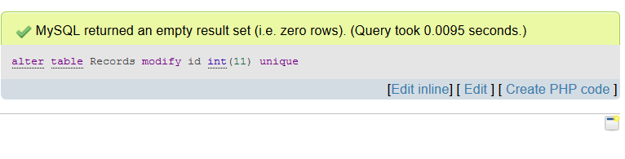

Continued….

